Phase 2 RTL Design Pipeline
Phase 2 has ten stages. The new microarchitecture planner (S3) sits between the readiness check and code generation: it turns the approved spec into a structured design plan, and every later stage reads that plan.

Inputs required from Phase 1

Mandatory
ID | Input | What to provide | Format | Used in
IN-01 | Requirements list | Every requirement with a unique, stable ID, title, clear description, priority, and source (document, page, exact quote) | JSON + Excel copy | S1, S2, S3, S9
IN-02 | Interface specification | Every port, property and method: name, direction, data type, width in bits, signedness, owning block or class; full method signatures | JSON + Excel copy | S3, S5, S6
IN-03 | Type definitions | All enums, structs and parameters, with names, base types and exact values | JSON | S3, S5
IN-04 | Operation / behaviour table | For each operation: ID, code, inputs used and their order, exact result, side effects (flags), behaviour at boundaries (overflow, zero, max/min) | JSON + Excel copy | S3, S8
IN-05 | Error and illegal-input behaviour | What happens for invalid codes, out-of-range values, and illegal call orders or sequences | JSON | S3, S5
IN-06 | Initial and reset state | Value of every stored item after creation and after reset; what reset clears | JSON | S3, S5
IN-07 | Resolved open questions | Every ambiguity with the agreed answer, approver and date; no unresolved questions left | JSON + Excel copy | S2, S3
IN-08 | High-level architecture | All blocks, modules or classes, their responsibilities and relationships (contains, extends, instantiates, connects); consistent with the requirements | Editable .puml or draw.io + PNG | S1, S3
IN-09 | Design kind and target | Synthesizable hardware or simulation-only model; target FPGA or ASIC if any | JSON field | S3, S5, S6
IN-10 | Specification baseline record | Spec version, approval status, approvers, date, Git commit or tag of the Phase 1 files | JSON fields | S2, S10

Mandatory for hardware designs
ID | Input | What to provide | Format | Used in
IN-11 | Clock | Clock names, frequency if known, clocked blocks, clock domains | JSON | S3, S6
IN-12 | Reset | Reset name, synchronous or asynchronous, active level, registers it resets | JSON | S3, S5
IN-13 | Timing behaviour | Per output: combinational or registered, latency in cycles, throughput, handshake protocol; timing diagrams where useful | JSON + diagrams | S3
IN-14 | Design constraints | Area, maximum frequency, power and other limits | JSON | S3

Recommended
ID | Input | What to provide | Format | Used in
IN-15 | Project coding rules | Language and version, naming and file conventions, one unit per file, allowed and forbidden constructs, required tools | Document or JSON | S5, S6
IN-16 | Smoke test vectors | One or a few cases per feature with inputs and exact expected outputs | JSON or CSV | S8
IN-17 | Existing RTL and reusable IP | Existing source files, versions, and whether to reuse, extend or replace each | Source files in Git | S3, S5
IN-18 | Verification requirements linked to IDs | The planned test or check for each requirement ID | JSON + Excel copy | S9

Not needed from Phase 1
Internal registers, datapath, FSM states and internal signals are decided in Phase 2 by the microarchitecture planner (S3); RTL code is written in S5.
Rule of thumb: if a testbench can observe it from outside, Phase 1 specifies it; if only the code can see it, Phase 2 decides it.

1. The pipeline at a glance
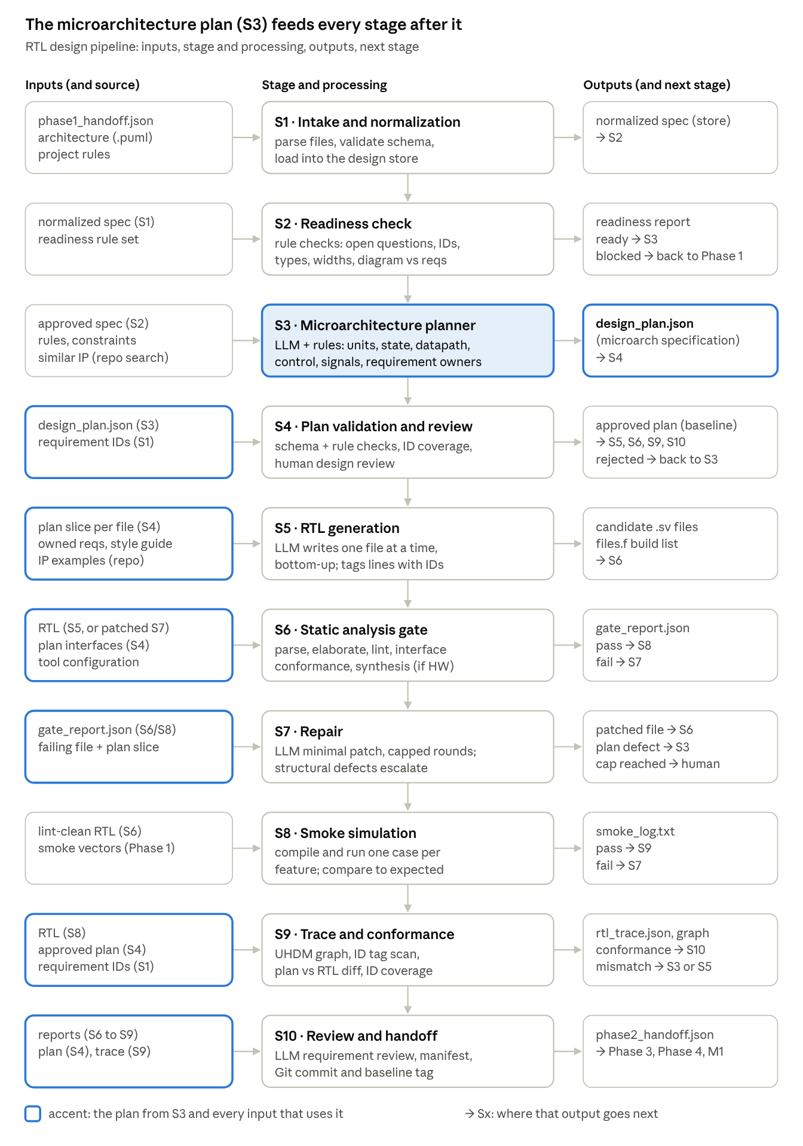
End-to-end Phase 2 pipeline · 10 stages, planner at S3
The accent marks the planner and the six stages that read its plan: everything after S3 is built from it or checked against it.
Stage | Gets its main input from | Sends its main output to
S1 Intake and normalization | Phase 1 agent, team rules | S2
S2 Readiness check | S1 | S3, or Phase 1 if blocked
S3 Microarchitecture planner | S2; re-plan requests from S4, S7, S9 | S4
S4 Plan validation and review | S3 | S5, S6, S9, S10; or S3 if rejected
S5 RTL generation | S4 (plan slices) | S6
S6 Static analysis gate | S5, S7 | S8, or S7 on failure
S7 Repair | S6, S8 | S6, or S3 for structural defects
S8 Smoke simulation | S6 | S9, or S7 on failure
S9 Trace and conformance | S8, S4 | S10; S3 or S5 on mismatch
S10 Review and handoff | S6 to S9 | Phase 3, Phase 4, Milestone 1

2. Stages S1 to S5: from spec to candidate code
The first five stages turn the Phase 1 handoff into a reviewed plan and then into source files. Only S3 and S5 use an LLM; S1, S2 and most of S4 are rules that never guess.

S1 · Intake and normalization
Purpose | Load everything Phase 1 produced into one consistent, queryable form
Inputs | phase1_handoff.json (requirements, interfaces, types, operations, decisions, open questions), architecture file (.puml or draw.io), project rules (language, design kind, style, toolchain), existing RTL if any
Comes from | Phase 1 agent; team (project rules); Git (existing RTL)
Processing | Parse each file; validate the JSON against the handoff schema; resolve cross-references (each operation → its unit, each interface → its owner); load everything into the design store with its ID
Outputs | Normalized spec in the design store; parse log (files read, schema errors)
Goes to | S2
Needs to work | A fixed handoff schema; stable IDs from Phase 1; readable architecture source (PlantUML or draw.io XML, not a PNG)
Components | JSON Schema / Pydantic validator; CSV and JSON readers; PlantUML or draw.io XML parser; SQLite design store

S2 · Readiness check
Purpose | Stop before any design work if the spec has gaps that would force the agent to guess
Inputs | Normalized spec (from the store); readiness rule set
Comes from | S1
Processing | Rule checks: no open questions left; every requirement has an ID and an owner component; every interface has a type and width; every operation has defined semantics; every decision is approved; diagram components match requirement components; clock and reset defined when the design is hardware
Outputs | readiness_report.json: ready or blocked, with a list of blocking items and warnings
Goes to | Ready → S3. Blocked → back to Phase 1 as questions
Needs to work | The rule set (written once per project type); a human or Phase 1 agent to answer blocking questions
Components | Rule engine (plain Python checks); design store queries. No LLM

S3 · Microarchitecture planner
Purpose | Decide how the design is built inside: units, state, datapath, control, internal signals, and which unit owns each requirement
Inputs | Approved spec; project rules and constraints; similar designs retrieved from the IP repository; on a re-plan, the reason (review comments, repair escalation, conformance mismatch)
Comes from | S2 (spec); IP repository; S4, S7 or S9 when a re-plan is requested
Processing | LLM proposes the plan in a fixed JSON schema; rules then check it (every requirement owned, no undefined signals, widths consistent, clocked units have a reset, no unit owns work outside the spec without being flagged as an added element)
Outputs | design_plan.json: the microarchitecture specification (structured, not code)
Goes to | S4
Needs to work | An approved spec with no open questions; a plan schema; design rules for the target (hardware or class model); optional IP repository for examples
Components | LLM with schema-constrained output; plan schema validator; rule checks; retriever over the IP repository
Section 4 covers S3 in detail.

S4 · Plan validation and design review
Purpose | Freeze an approved plan before code is written, so code generation never works from a plan nobody checked
Inputs | design_plan.json; requirement IDs; list of added elements
Comes from | S3; S1 (requirement IDs)
Processing | Automatic: schema check, every requirement ID owned exactly once, every interface in the spec appears in the plan with the same name and type. Human: design review of structure and of each added element (approve or reject with a comment)
Outputs | Approved plan (versioned baseline) and per-file plan slices; or a rejection with comments
Goes to | Approved → S5 (slices), S6 (interfaces), S9 (conformance), S10 (manifest). Rejected → S3
Needs to work | A reviewer (designer or lead); the coverage rules
Components | Rule checks; review UI or a simple approve file; Git to version the plan

S5 · RTL generation
Purpose | Write the source code, one file at a time, exactly as the plan describes
Inputs | One plan slice (one file: its ports or properties, internal signals, behaviour, owned requirement IDs); the requirement text for those IDs; interface signatures; coding style guide; optional matching IP examples
Comes from | S4 (plan slices); S1 (requirement text); IP repository
Processing | LLM writes files bottom-up in the plan's build order. Each line that implements a requirement gets a // @ID tag. Files are written into the workspace, never run by the LLM
Outputs | Candidate .sv / .svh files; files.f build list in compile order
Goes to | S6
Needs to work | An approved plan; a style guide; file-write access to the RTL folder only
Components | LLM (code generation); prompt templates per file kind (module, package, class); file writer tool; IP retriever

3. Stages S6 to S10: checking, repairing, tracing, handing off
These stages judge the code with real tools and link it back to the plan and the requirements. Pass or fail is always decided by a tool or a rule, never by an LLM.

S6 · Static analysis gate
Purpose | Prove the code parses, elaborates, lints clean and matches the planned interfaces, before anything is simulated
Inputs | Candidate RTL and files.f; planned interfaces (names, directions, types, widths); tool configuration (flags, waivers)
Comes from | S5 (first pass) or S7 (patched files); S4 (plan interfaces)
Processing | Parse and elaborate the full design; lint with all warnings on; style lint; compare every port or property against the plan; synthesis check when the design is hardware (latches, multiple drivers); turn every tool message into a structured record (file, line, rule, text)
Outputs | gate_report.json: pass/fail per check plus the structured message list
Goes to | Pass → S8. Fail → S7
Needs to work | Tools installed with fixed versions; a parser for each tool's output format; an agreed waiver list
Components | Verilator (--lint-only -Wall); Verible lint; Surelog/UHDM for full parse; Yosys (hardware mode only); interface-conformance script; log parsers. No LLM

S7 · Repair
Purpose | Fix tool-reported problems with the smallest possible edit, and send design-level problems back to the planner instead of patching around them
Inputs | gate_report.json (or a smoke failure); the failing file; the lines around each error; that file's plan slice; the rules on what may not change (names fixed by the spec)
Comes from | S6 or S8
Processing | Classify each error: local (syntax, width, missing else, naming) or structural (missing signal, wrong unit boundary, plan contradiction). Local: LLM patches only the reported lines. Structural: escalate. Count rounds; stop at the cap (for example 5)
Outputs | Patched file; or an escalation record; or a human hand-off when the cap is reached
Goes to | Patched file → S6. Structural defect → S3 (re-plan). Cap reached → human
Needs to work | Exact tool messages with file and line; the plan slice; a round counter
Components | LLM (patching); error classifier (rules first, LLM for unclear cases); diff tool to confirm the edit stayed small

S8 · Smoke simulation
Purpose | Show the design builds into a simulation and does the basic job, one case per feature. It is a gate, not verification
Inputs | Lint-clean RTL; smoke vectors from the Phase 1 handoff (a few per feature, not the full test set)
Comes from | S6; Phase 1 (verification_hooks.smoke_vectors)
Processing | Generate a tiny test from the vectors; compile and run; compare outputs with the expected values; record pass/fail per case
Outputs | smoke_log.txt and a pass/fail summary
Goes to | Pass → S9. Fail → S7
Needs to work | A simulator that supports the language features used; smoke vectors with expected values
Components | Verilator --binary (or Questa, Icarus); smoke-test template; result parser

S9 · Trace and conformance
Purpose | Prove the code is what the plan said and covers every requirement, and record the requirement-to-line links
Inputs | Final RTL; approved plan; all requirement and decision IDs
Comes from | S8 (RTL); S4 (plan); S1 (IDs)
Processing | Parse the design into a graph (units, signals, instances, "drives" edges); scan // @ID tags; compare the graph with the plan (every planned unit and signal exists, nothing unplanned appeared); check every ID is implemented or explained
Outputs | rtl_trace.json (ID → file:line); design graph; conformance_report.json; traceability CSV
Goes to | S10. Plan mismatch → S3 (plan wrong) or S5 (code wrong). The graph and trace also go to Milestone 1
Needs to work | Consistent ID tags in code; the approved plan; a parser that understands the full language
Components | Surelog/UHDM; graph builder (NetworkX); tag extractor; plan-vs-graph diff script

S10 · Review and handoff
Purpose | Package a verification-ready baseline that the next phases can trust
Inputs | All reports from S6 to S9; approved plan; trace; list of added elements and deviations
Comes from | S6, S8, S9; S4
Processing | LLM reviewer reads each requirement beside the lines that implement it and flags suspected mismatches for a human (it does not fix them). Write the manifest. Commit and tag the baseline in Git
Outputs | phase2_handoff.json (files, build list, gate results, trace summary, added elements, deviations, open items); review notes; Git tag
Goes to | Phase 3 (DUT + trace), Phase 4 (build list), Milestone 1 change observer (trace + graph + baseline commit)
Needs to work | All earlier gates passed; reviewer sign-off on flagged items
Components | LLM (review); manifest writer; Git

4. The microarchitecture planner in depth
The planner (S3) receives the approved spec and produces design_plan.json: a structured microarchitecture specification, not code.
After review (S4) it becomes the versioned contract that code generation follows and that analysis checks the code against.

Where it fits and why there?
It sits after the readiness check and before any code.
Earlier, the spec might still have gaps; later, code would be written without an agreed structure.
It belongs to Phase 2, not Phase 1: Phase 1 fixes what the design does from outside, the planner decides how it is built inside.

What it receives
Input | From | Used to decide
Requirements with IDs | S1 store (approved by S2) | What every unit must do; which unit owns each ID
Interfaces, types, widths | S1 store | External ports or properties each unit must expose exactly
Operations and decisions | S1 store | Behaviour each unit implements
High-level architecture | S1 store (from the .puml) | The top-level split it must respect
Project rules | Team | Hardware module vs class model, naming, one unit per file, allowed constructs
Constraints | Phase 1 | Clock, reset type and polarity, latency, area or performance limits (hardware only)
Similar designs | IP repository | Proven structures to reuse (a FIFO pointer scheme, an ALU dispatch)
Re-plan reason | S4, S7 or S9 | What was wrong with the previous plan

What it must decide
- Units: which modules or classes exist, and their hierarchy (instances, extends, contains).
- Unit interfaces: every port or property and method, with direction, type and width.
- State: registers, memories, counters and status flags, with width and reset value.
- Control: whether an FSM is needed; its states and transitions.
- Datapath: how each result is computed (operators, internal widths such as a 33-bit sum for carry).
- Timing: which outputs are combinational and which are registered, and the latency of each (hardware only).
- Internal signals: names, widths, and which unit drives each.
- Ownership: which unit implements which requirement and decision IDs.
- Build order: dependency order for files.
- Added elements: anything not named in the spec (helper method, extra register), each with a reason, flagged for approval.

What it produces
One JSON file, design_plan.json, validated against a schema and stored as a versioned record. It is an artifact (a file), a structured representation (typed fields a program can read), and a specification (the contract for code). It is never code.
Example for the ALU class model (excerpt):
{
"plan_version": 1,
"spec_version": "1.1",
"mode": "class_model",
"units": [
{"name": "base_alu", "kind": "class", "file": "rtl/base_alu.svh",
"owns": ["FR-001", "FR-002", "FR-003", "FR-004", "FR-005"],
"state": [{"name": "operand_A", "type": "int", "reset": 0},
{"name": "alu_op", "type": "alu_op_t", "reset": "OP_SEL_B"}],
"methods": [{"sig": "virtual function void execute()", "role": "overridden by each ALU"}]},
{"name": "arithmetic_alu", "kind": "class", "extends": "base_alu",
"file": "rtl/arithmetic_alu.svh", "owns": ["FR-007", "OP-001", "OP-002", "OP-003", "OP-004", "OP-005", "OP-006", "OP-007"],
"state": [{"name": "carry", "type": "bit", "reset": 0, "from": "D-005"}],
"datapath": [{"op": "OP_ADDC", "compute": "wide[32:0] = {0,A} + {0,B} + carry",
"result": "wide[31:0]", "carry_out": "wide[32]"}]},
{"name": "CPU", "kind": "class", "file": "rtl/CPU.svh",
"contains": [{"name": "l_alu", "type": "logical_alu"}, {"name": "a_alu", "type": "arithmetic_alu"}],
"control": {"kind": "dispatch", "rule": "0000-0110 -> a_alu, 0111-1101 -> l_alu, else invalid"}}
],
"build_order": ["cpu_pkg.sv", "base_alu.svh", "logical_alu.svh", "arithmetic_alu.svh", "CPU.svh"],
"added_elements": [{"name": "execute()", "reason": "lets CPU dispatch through a base_alu handle", "approval": "pending"}]
}
For a hardware design the same schema carries clock and timing. Excerpt for the sync FIFO:
{"mode": "hardware",
"clock_reset": {"clock": "clk", "reset": "rst_n", "reset_type": "async", "active": "low"},
"units": [{"name": "sync_fifo", "kind": "module",
"state": [{"name": "wptr", "width": "AW+1", "reset": 0, "note": "extra bit = lap counter"},
{"name": "rdata", "width": "WIDTH", "reset": 0, "registered": true, "owns": ["R4"]}],
"combinational": [{"name": "full", "expr": "lap bits differ and address bits equal", "owns": ["R1"]}],
"fsm": null}]}

How the output is passed on
- S3 writes design_plan.json to the design store as a new plan version.
- S4 checks and reviews it. On approval it is committed to Git and marked as the baseline plan.
- S4 splits it into per-file slices: each slice holds one unit plus the text of the requirement and decision IDs it owns. S5 gets one slice per prompt, so the LLM sees only what that file needs.
- S6 reads the plan's interfaces to check the code's ports and properties.
- S9 reads the whole plan to compare it with the structure parsed from the code.
- S10 copies the plan version and the approved added elements into the handoff manifest.

Which stages depend on it
Stage | Uses | Why
S4 Plan review | Whole plan | Approves or rejects it
S5 RTL generation | Per-file slices | Writes each file from its slice
S6 Analysis gate | Unit interfaces | Interface-conformance check
S7 Repair | Slice of the failing file | Knows what the file must contain; spots plan contradictions
S9 Trace and conformance | Whole plan | Plan-vs-code comparison
S10 Handoff | Plan version, added elements | Recorded in the manifest
Phase 3 (optional) | Internal state and signals | White-box assertions or coverage only; main tests still come from the spec

How it interacts with generation and analysis
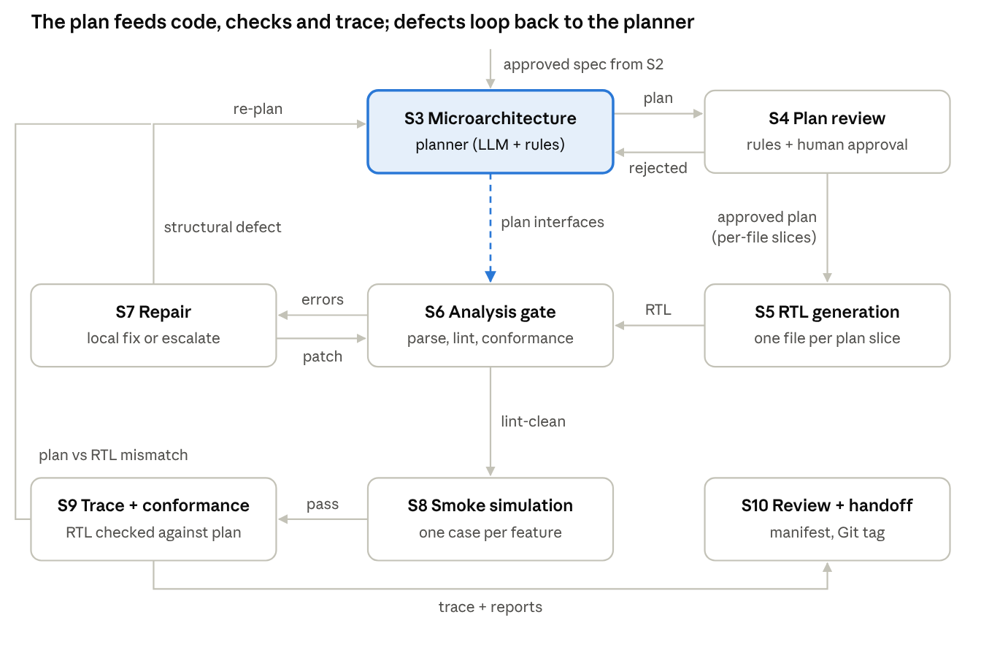
Planner interactions · the plan flows to generation and analysis, three loops return to it
The plan travels forward as slices to S5 and as interfaces to S6 (dashed). Three loops return to the planner, so problems are fixed at the level where they started:
Loop | Trigger | Planner action
S4 → S3 | Reviewer rejects the plan or an added element | Revise with the review comments
S7 → S3 | Repair classifies an error as structural (missing signal, wrong unit boundary, plan contradicts spec) | Re-plan the affected unit; only its files are regenerated
S9 → S3 | Code structure differs from the plan and the plan is the cause | Correct the plan; S9 sends code-caused mismatches to S5 instead
Local errors (syntax, widths, naming) never reach the planner: they stay in the S6 ↔ S7 loop. Each new plan version goes through S4 again before any code changes.

5. Components needed to build the pipeline
The pipeline needs one LLM, about ten deterministic components and two data stores. Most of the work is in the deterministic parts: they are what make the LLM's output checkable.
Component | Type | Used in | What it does | Options
Handoff schema + validator | Rule-based | S1, S3, S4 | Defines and checks the shape of phase1_handoff.json and design_plan.json | JSON Schema, Pydantic
File parsers | Parser | S1 | Read JSON, CSV/Excel, PlantUML or draw.io XML | Python json, csv, openpyxl, PlantUML text parser, xml.etree
Design store | Database | All | Holds the normalized spec, plan versions, gate results, trace; queried by ID | SQLite (one file per project)
Readiness rules | Rule-based | S2 | Blocking and warning checks on the spec | Plain Python functions, one per rule
LLM with structured output | AI model | S3, S5, S7, S10 | Plans, writes code, patches, reviews | Any capable code model; JSON mode or tool calling for S3
Prompt templates | Config | S3, S5, S7, S10 | One template per task and per file kind (module, package, class) | Jinja2 or Python f-strings
IP repository + retriever | Repository + search | S3, S5 | Past designs and reusable blocks; returns similar examples | Git repo of RTL; embedding index (FAISS, Chroma) or keyword search
Plan rules | Rule-based | S3, S4 | Every requirement owned once, widths consistent, clocked units reset, added elements flagged | Python checks on the plan JSON
SystemVerilog parser / elaborator | Parser + AST | S6, S9 | Full-language parse into a structural model (UHDM) | Surelog + UHDM; Verilator's internal AST for lint
Linters | Tools | S6 | Rule-level and style checks | Verilator -Wall, Verible
Synthesis checker | Tool | S6 (hardware only) | Latches, multiple drivers, unbuildable logic | Yosys synth + check -assert
Simulator | Tool | S8 | Build and run the smoke test | Verilator 5 --binary, Questa, Icarus
Log parsers | Rule-based | S6, S8 | Turn tool text into file/line/rule records | Regex per tool
Error classifier | Rules + LLM | S7 | Local vs structural error | Rules for known message codes; LLM for the rest
Graph builder | Structural representation | S9 | Units, signals, instances and "drives" edges from UHDM | NetworkX
Tag extractor + diff | Rule-based | S9 | // @ID → file:line; plan vs graph comparison | Python script
Version control | Repository | S4, S10 | Version the plan and the code; baseline tag | Git
Orchestrator | Framework | All | Runs stages, routes pass/fail, caps loops, pauses for humans | LangGraph, or a plain Python state machine

What to build first
- Schemas for the Phase 1 handoff and the design plan. Every other component depends on them.
- The design store and S1 (parsers + loader).
- S6 gate with Verilator and Verible. Test it on hand-written code, including code broken on purpose.
- S5 + S7 (generation and repair) working from a hand-written plan.
- S3 + S4 (planner and review), replacing the hand-written plan.
- S9 trace and conformance, then S10 handoff.
- S2 readiness rules last; they grow as you find what earlier runs needed.
This order puts the judge (S6) in place before anything that needs judging, and lets you test the planner against a known-good hand plan.

6. Artifacts and data contracts
Every stage hands over a file with a fixed format, so any stage can be rerun or replaced without touching the others.
Artifact | Kind | Format | Produced by | Consumed by
phase1_handoff.json | Specification | JSON (schema) | Phase 1 agent | S1
Architecture file | Structural representation | PlantUML / draw.io XML | Phase 1 agent | S1
Project rules | Configuration | YAML or JSON | Team | S1, S3, S5, S6
Normalized spec | Database records | SQLite | S1 | S2, S3, S4, S5, S9
readiness_report.json | Report | JSON | S2 | S3 (go) or Phase 1 (questions)
design_plan.json | Microarchitecture specification | JSON (schema) | S3 | S4
Approved plan + slices | Specification (versioned) | JSON in Git | S4 | S5, S6, S9, S10
RTL source | Code | .sv, .svh | S5, S7 | S6, S8, S9, Phase 3
files.f | Build configuration | file list | S5 | S6, S8, Phase 4
gate_report.json | Report | JSON | S6 | S7, S10
Escalation record | Report | JSON | S7 | S3
smoke_log.txt | Report | text + summary | S8 | S7, S10
Design graph | Structural representation | NetworkX / GraphML | S9 | S10, Milestone 1
rtl_trace.json | Trace | JSON (ID → file:line) | S9 | S10, Phase 3, Milestone 1
conformance_report.json | Report | JSON | S9 | S3 or S5 (on mismatch), S10
phase2_handoff.json | Manifest | JSON | S10 | Phase 3, Phase 4, Milestone 1
Baseline tag | Version | Git tag | S10 | Phase 6 regression, Milestone 1 diffs

